Investing in Children Membership Award™

Re-evaluation of Burnopfield Primary School

Introduction

Burnopfield Primary School is situated in a village at the edge of County Durham catering for 369 children, 37 of which are in the Nursery provision. The school ethos is, ‘We inspire, challenge and care.’ The staff within Burnopfield Primary are: Passionate about inclusion, seeing the whole child and supporting them to find their strengths and talents, whatever they may be. In addition to the Investing in Children Membership Award™, Investing in Children has worked closely with Burnopfield Primary in recent years including the delivering of a Peer Mentoring programme, awareness raising assemblies, focus group discussions and workshops with a focus on pupil wellbeing.

For the purpose of this re-evaluation, I visited the school on the morning of the 8th July at the end of the academic year and had the pleasure of meeting with 15 young people from Years 1 up to Year 6. I’d like to say a special thank you to: Gabriella, Ella, Charlie, Nuala, Louie, Noah, Nieve, Jasmine, Grace, Dainton, Charlotte, Safi, Olivia, Drew and Lincoln?

Evidence of Dialogue and Change

Part 1 – Evidence of Dialogue resulting in Change from Children and Young People

Student Council
Within Burnopfield Primary School there are a number of groups that young people can join to have voice, take on some responsibility and inform the work of the school.

One of the regular opportunities for dialogue and change is the schools Student Council. One of the young people described the Student Council as: “You can give ideas for things if they’re not working out to make them better.” As well as reviewing things the children would like to improve, it is also a forum to put forward ideas for things the children would like to take part in outside of the school curriculum. One young person commented: “We give ideas for what we want to do.”

I was interested to find out how the children became members of the Student Council and I was told that the Children were able to put themselves forward for a range of roles based on what they wanted to be involved in and that each role was voted for by the other children in their class: “In most classes we do a classroom vote and in some the teacher puts the names in a hat and picks out a name from the people that put themselves forward.”

“You put your hand up for the meetings you want to do and then they do a vote.” In addition to Student Council the children within school can also put themselves forward for Reading Champions, Web Warriors and Eco Club.

Some of the examples shared with me included: “We did break the rules day.”

“For break the rules you could break any amount of rules for 50p each. The rules included wearing makeup, nail varnish, non-uniform and bringing sweets into school for breaktime.” One of the children also said that a benefit of break the rules day meant that children could express themselves and be unique and dress in a way that tells other people about them.

Another recommendation that had been implemented through the Student Council was: “We suggested playground buddies at break time to help the little ones that need help.”

Reading Champions
Within Burnopfield Primary School there are a group of children called the Reading Champions whose mission is: ‘to get all children interested in books’. The children who are Reaching Champions told me about how they were able to put forward books they wanted the school to purchase to encourage other children to read: “We votes for books that we wanted other children to read and we’ve got the books the children voted for.”

Clubs
There are lots of different clubs for children at Burnopfield Primary to join including after school clubs and some that take part during the school day.

ECO Club
The children who attend ECO club have regular tasks which they do in school including planting and watering plants, planting flowers and fruit as well as helping to keep the school and the community tidy: “We planted flowers and strawberries in the school forest.”

“We organised for every class to go and do a litter pick and when we saw some of the locals they helped us.”

Board Game Club
One of the after school clubs is Board Game club and children mentioned how they have recently been donated some new games which were chosen by the children: “The Happy Shopper gave the Board Games club new games and the children chose what games they wanted.”

Wellbeing Club
A couple of years ago some children in school were trained as Peer Mentors through a project with Investing in Children. Off the back of that the Children set up a Wellbeing club: “Peer Mentors run a club, the Peer Mentors left last year so we’ve got new ones and every Monday afternoon we have a wellbeing club for people who need help to calm down or who are anxious.”

Rainbow Ambassador
Another helpful role in school that children can sign up to is a Rainbow Ambassador: “You can sign up to do it to do jobs around school like assemblies and stuff.”

“Rainbow Ambassadors said that we needed more dolls in school as there was a lack of black and disabled dolls so parents brought some in and now we’ve got lots of them.”

Dining Hall & Lunchtime
Art work
The children told me how the dinning hall area had recently been given a makeover and that the children chose a design which was then painted by a creative member of staff Mrs Mourn: “We got a painting done because people thought the walls were dull. It’s got animals and fruit and vegetables on and the children chose the design. Mrs Mourn has done paintings all around the school, someone in Year 1 did the designs and she painted it.”

Menu’s
As well as improving the atmosphere of the dining hall with the new paintings, the children have also been involved in choosing new food options for the school dinners menu: “We got to pick meals to try out like panini’s, Chinese chowmein and vegi meals, everyone had the chance to do it and give their ideas.”
To make things fun the children mentioned how the kitchen staff create themed menus for special occasions: “We had a themed desert for the 4th July and at Halloween we had witches fingers hotdogs.”

Lunch Leaders
Lunch Leaders is a role that children can take on during the busy lunch period to help other children and lunch staff. This is something that one of the Year 6’s took upon themselves to do which since be turned into a specific role that other children can do: “I just started doing it, helping clear the plates and helping the smaller children and then they made lunch leaders a role and other people now do it as well.”

OPAL
OPAL stands for Outdoor Play and Learning and is something that the children told me has improved their experience of breaktime in school. The children told me how OPAL encourages children to try new things and to take risks however the children have been learning about what risks are safe to take: “We have OPAL assemblies with risks and benefits and then we discuss different things and what we can do and what the risks might be.” Every week children meet with the Deputy Head Teacher Mr Robertshaw to discuss OPAL and within these meetings they plan the assemblies for the rest of the school which includes how to take risks without hurting themselves.

Play equipment
The children talked about all the new areas and equipment that has been added to the school through OPAL based on the children’s ideas: For new play stuff we vote and what we want, I suggested a Mud Kitchen and we’ve got one.”

“We’ve now got a hammock, sandpit, an obstacle course, trim trail and a boat, we’ve got a canoe and sometimes we fill it up with water.” When the school were adding climbing bars to the outdoor area the children asked for different sizes so that they were accessible to as many children as possible: “We were getting two types of bars but we asked for three different sizes so now we’ve got small, medium and bigger ones.”

“We’ve got a builders yard to make dens and lose parts, a stage, the forest where we do forest school. We had some things before but we decided most of what we’ve got.”

Play Leaders
To support OPAL children have been trained as Play Leaders to assist other children during break time: “OPAL Play Leaders stay on the yard and help people if there is a problem like with their friends or they need something sorting out.”

Zen Den
A new area has been created which is available at lunchtime specifically for children who would benefit from some quiet time, the name for the area was chosen by the children: “Some people at lunch wanted a place to chill so we made a Zen Den and we voted for the name and Zen Den was the winner.”

“You can go there and sit and talk to a friend of there’s things to do so you’re focussed like blocks and Juplo or you can just chill if you don’t want to do anything.”

“There’s red beanbags, they’re huge and fit more than two people on.”

Golden Time
The children told me how Golden Time is something that happens at the end of each term where children get to choose activities that they’d like to do with their friends: “Golden Time is extra ordinary time like a treat at the end of every term. Last term we had board games and share were you bring in your own board game or share and play each other’s board games.”

Longer lunchtime
The length of time the children have at lunchtime to play has been increased based on the feedback from the children: “We used to hardly have time at lunchtime, we got half an hour but now we get 45minutes.”

Trips
Each year children have the opportunity to go on school trips and at the end of the year the children are asked for feedback to help the school plan trips for the following year: “Our class chose what was the best trip to do next year out of all of the trips we’d been on. It can be expensive and people can’t afford to do all of the trips so we chose the best one. We said the Hancock was the best.

Dubai
Within the group there were some children that had the opportunity to go to Dubai with their school. The children were selected by school after receiving a government grant: “15 people went to Dubai, if more people wanted to go their name was put into a hat. People got picked who wouldn’t get to go on holiday. People went to the hotel and met with kids from different schools and learnt about different countries and also went to a waterpark. We went to the tallest tower in the worlds as well.”

School visitors and Assemblies
The children I met with told me how they really like it when visitors come into school to talk to them during assemblies. Often organisations are invited into school to help educate the children based on things that are of interest or relevant to what is happening in the local community. An example of this is when the police came into school to talk about hate crime and anti-social behaviour after children raised about issues in their local park.

As part of the schools mission to encourage children to read, the children told me how they have invited local authors into school to talk about the books that they’ve written.

The children also said they had recently started doing more singing in assemblies at their request: “We’ve been doing singing assemblies as we haven’t done them in a while so we’ve started learning new songs to sing on a Thursday.”

Fundraising
Across the school the children told me how they like to find opportunities to raise money for charity and for the school and that throughout the year they plan and take part in a range of activities to fund raise: “We did a run to raise money for cancer and raised over £2000.”

“We also made and sold bracelets and raised over £100 for Children in Need and Cancer, we split it between the two charities.”

Part 2 – Additional evidence of Dialogue resulting in Change provided by the organisation

Below is additional information which has been shared by the school and included as additional evidence of dialogue and change:

Nurture provision
Sometimes a pupil’s ‘voice’ may be silent and children’s actions and behaviour alert staff to their needs. At Burnopfield School we have created a nurture provision (The Nest) to support some of these children.

The Nest has been created in a spare classroom in our KS2 building. It has been adapted and resourced with equipment to support the needs of the children. A kitchen area with a sink was recently added. Children are identified to access the Nest several times a week. They experience circle time activities, RSHE, structured play and activities to help with their emotions. It has been in place since November and feedback from children tells how much they all enjoy going there.

Below are screenshots of feedback from children about their experience of Nurture:
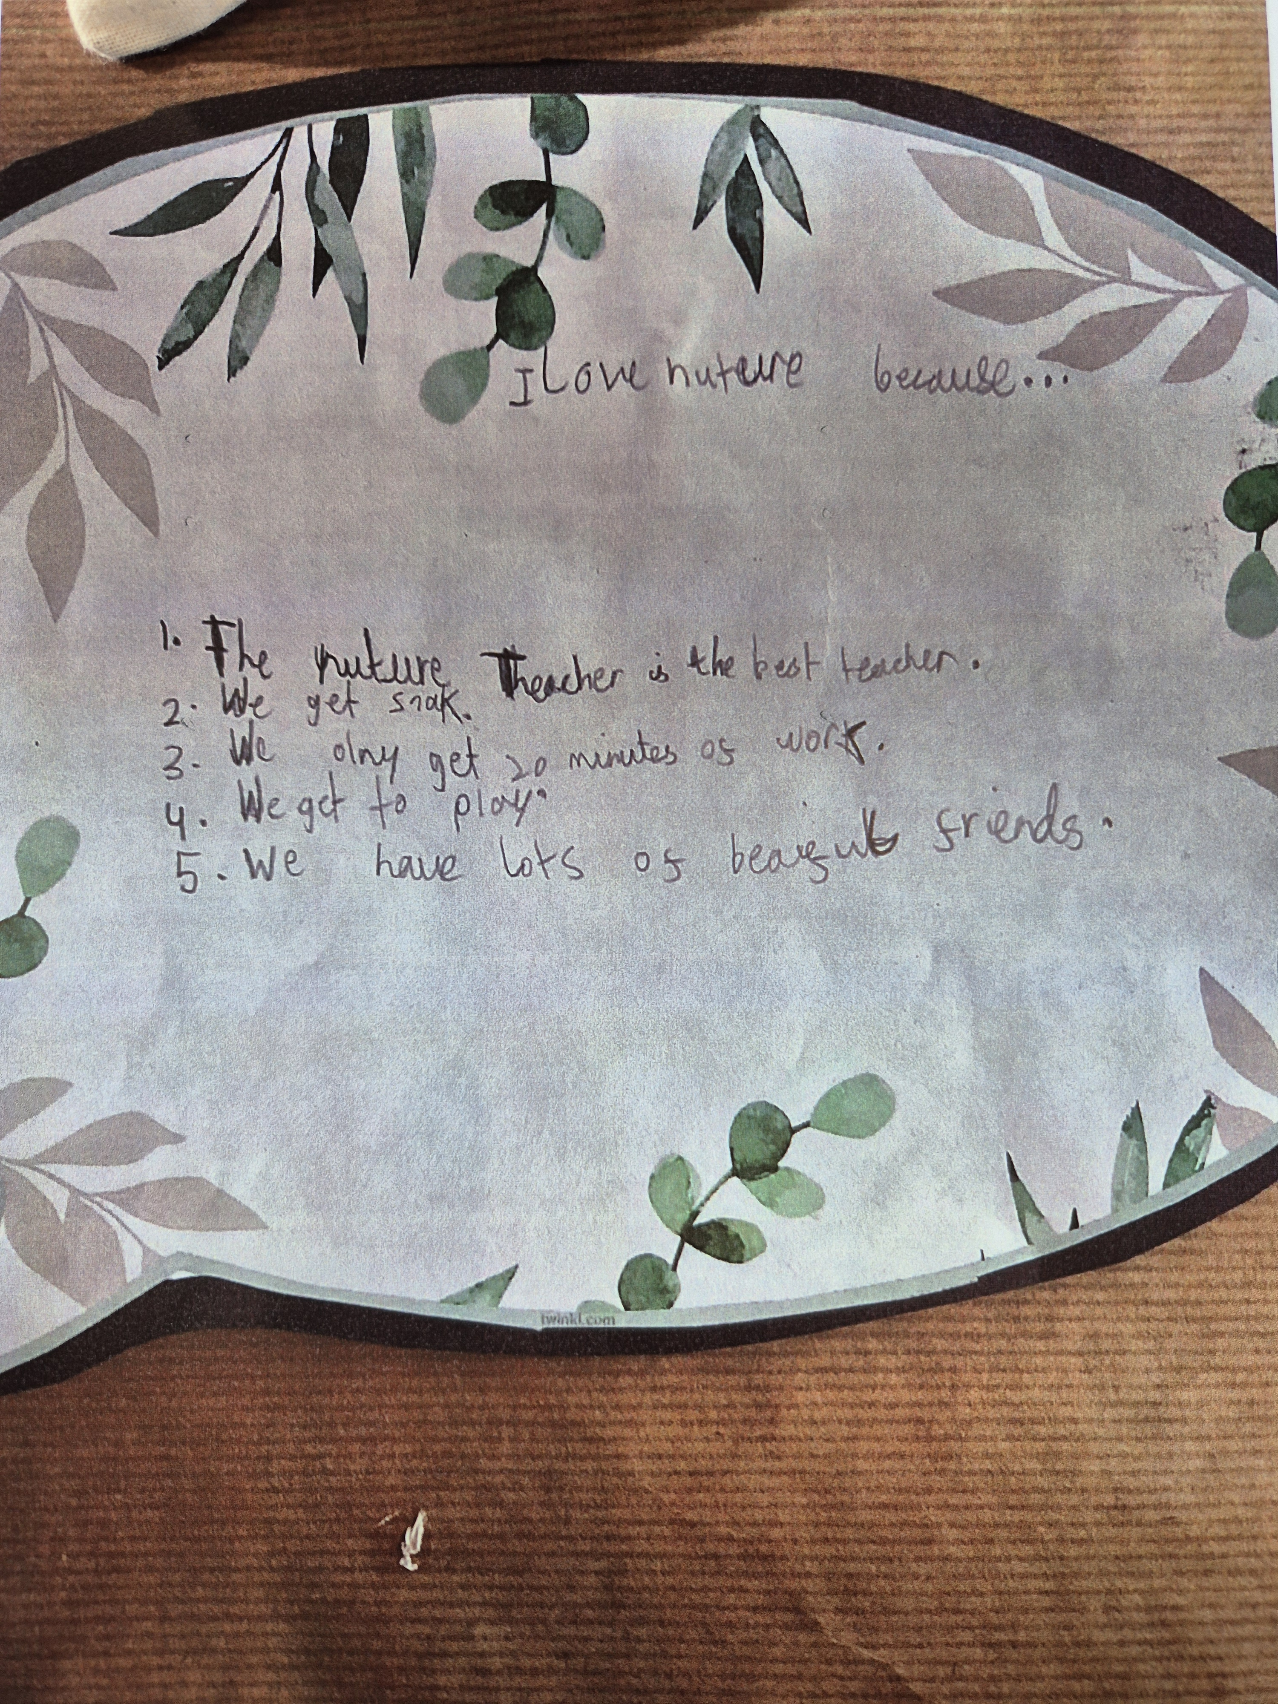
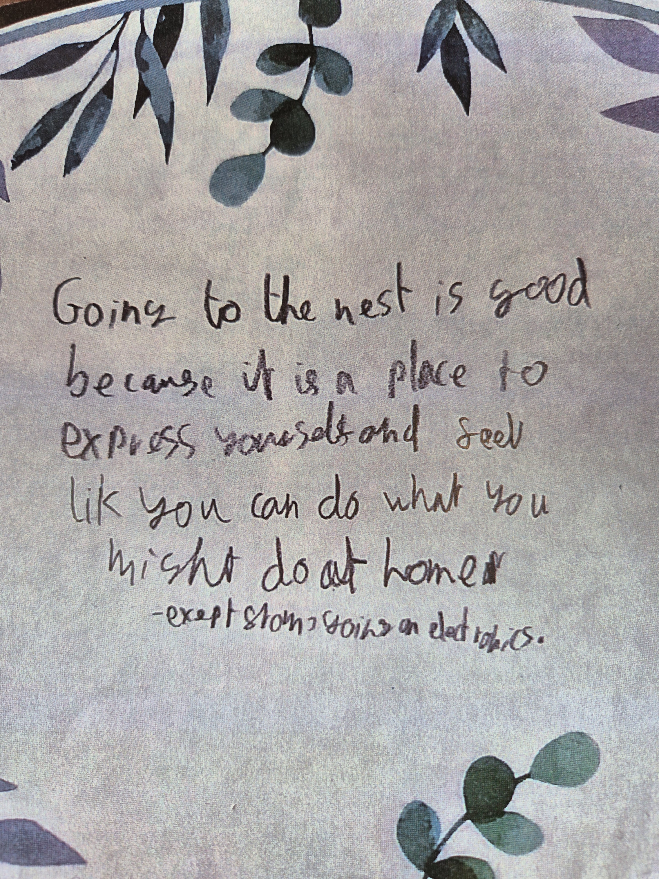
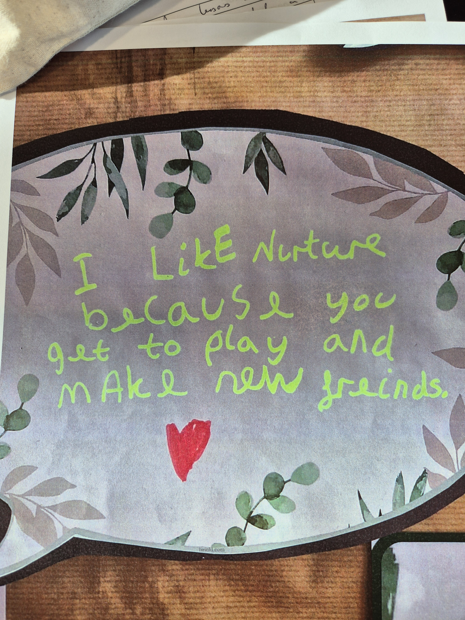

One of the children who was unable to attend the meeting with me was keen to share her involvement in Student Council meetings so took the time to write about some of the things which she had put forward within a recent meeting:

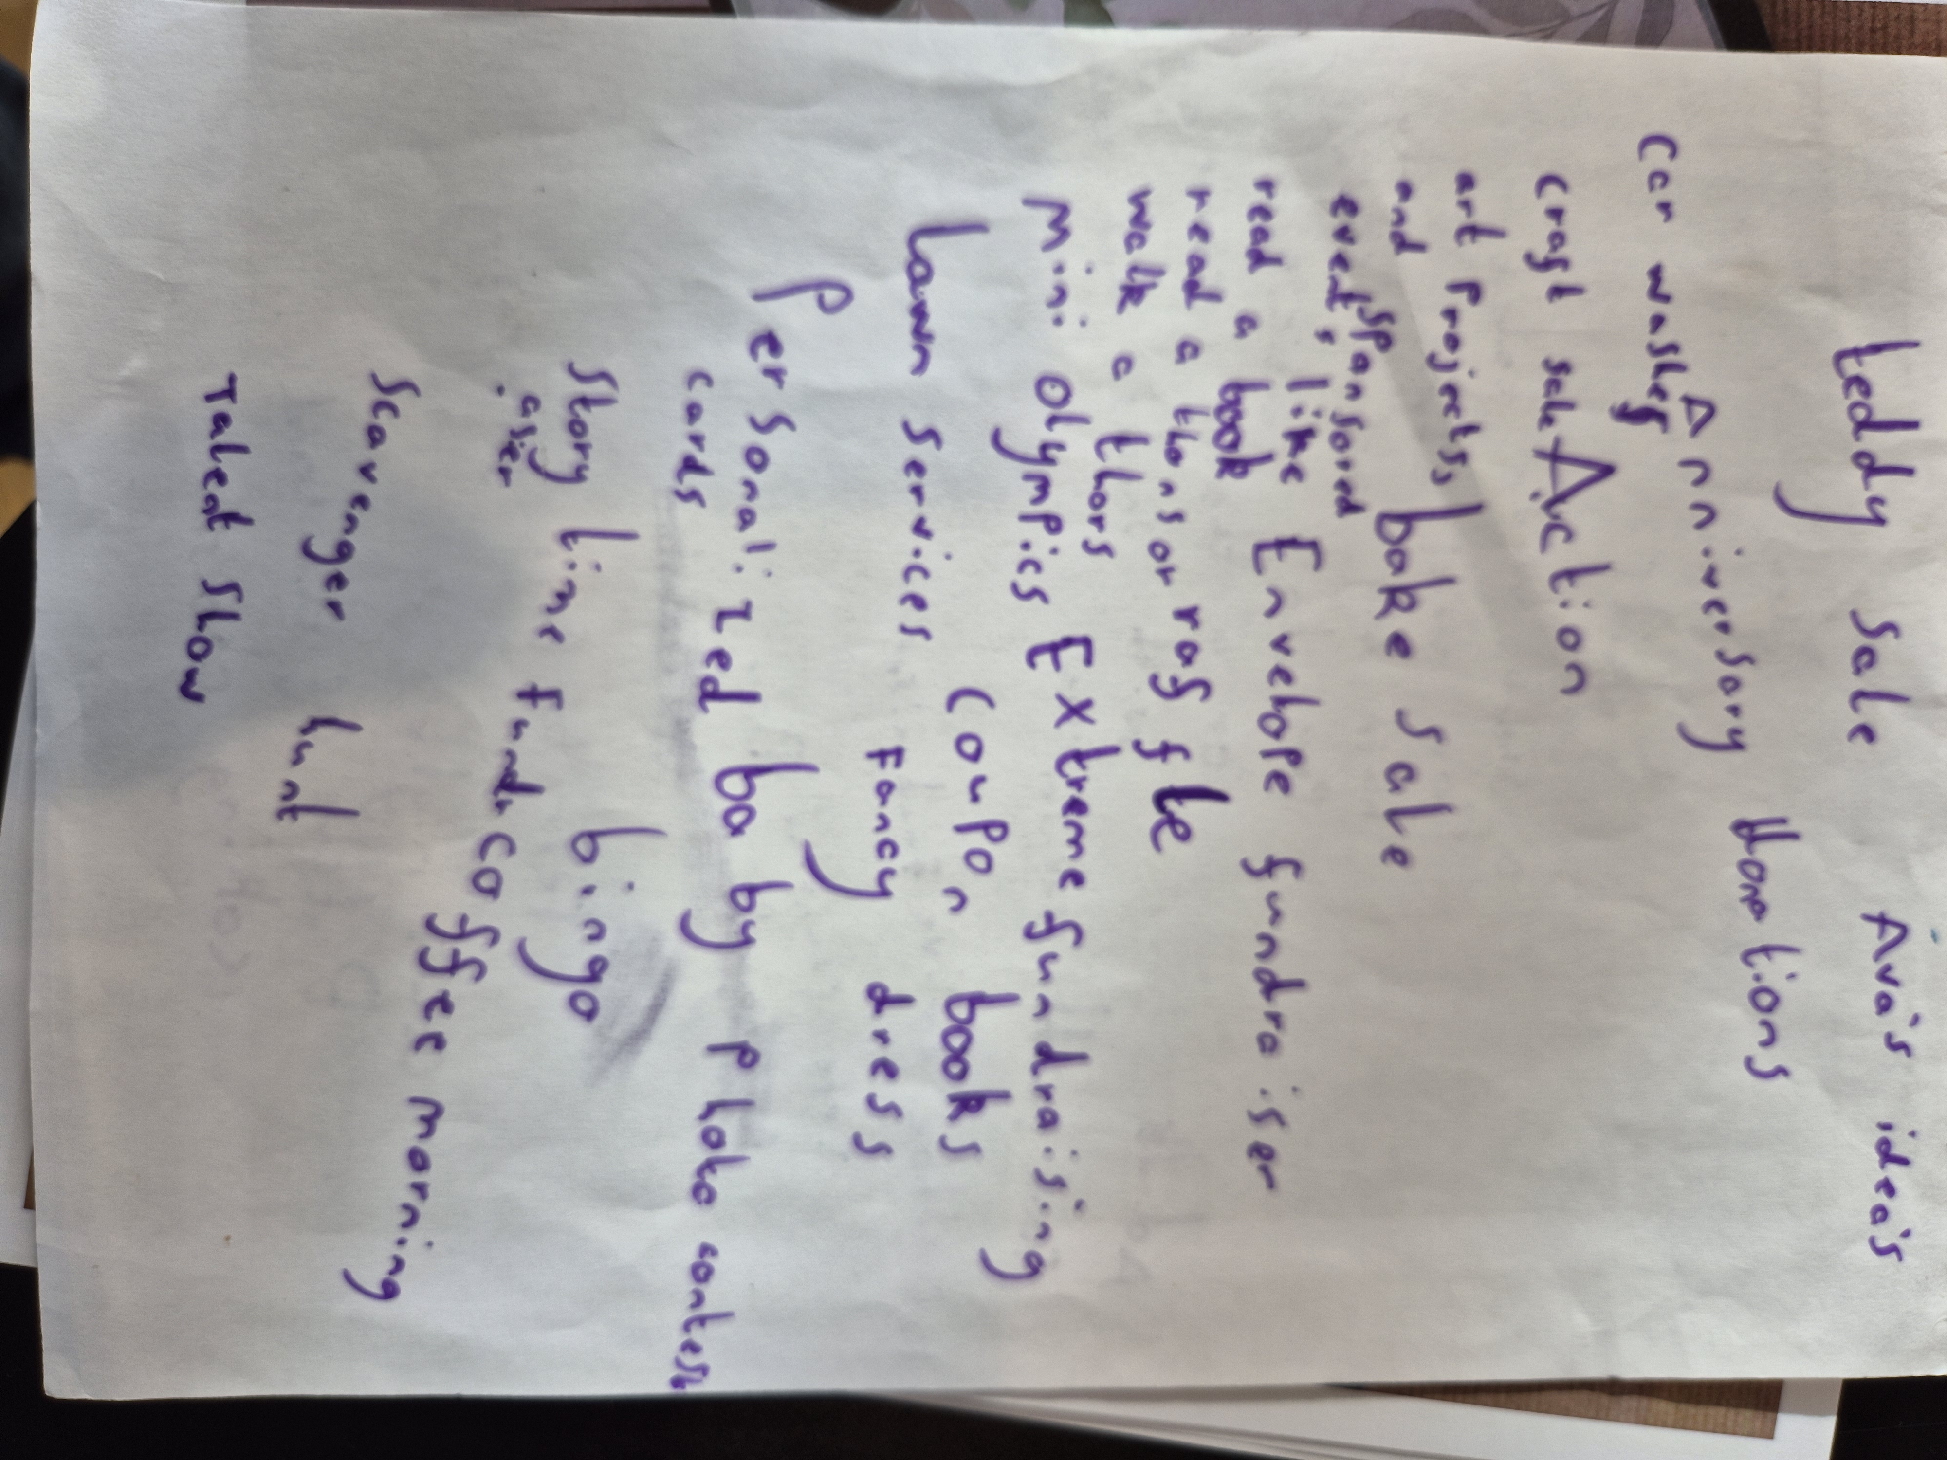

Recommendations

Part 1 – Recommendations from children and young people

There were no recommendations put forward by the children as part of this re-evaluation.

Part 2 – IiC recommendations

Continue to provide lots of meaningful opportunities for children to have a voice in school.

Conclusion
It was fantastic to spend time with the children as part of this re-evaluation who were all a real credit to the school. The children spoke with real enthusiasm and shared lots of examples of how they have been meaningfully involved in dialogue that has resulted in change. The children talked about how the staff across the school go over and above to provide fun engaging lessons as well as extra curricular activities and additional opportunities that make school such a caring and nurturing environment that children look forward to attending.

When asked if Burnopfield Primary should receive the Investing in Children Membership Award™ the children commented: “Yes because they work hard and put the time in to make nice lessons.”

“##### brought in loads of biscuits and treats for us and bought us sweets for transition days.”

“They make costumes for us for performances and used their own washing machines to wash our football kits.”

Thank you to all of the children for speaking to me and making me feel so welcome and Congratulations to everyone at Burnopfield Primary School for once again achieving the Investing in Children Membership Award™

Endorsement by Young People

Signing sheet (optional) – signatures of children and young people

Chris Affleck
Project Manager
July 2025

Investing in Children CIC
Investing in Children Membership Award™ is a registered Trademark™.
Investing in Children CIC is a company (number 08428687) registered in England and Wales:
The Sjovoll Centre, Front Street, Framwellgate Moor, Durham, DH1 5BL
Tel: 0191 307 7030. Company Reg. 8428687
info@investinginchildren.net www.investinginchildren.net

